Team: Magic

Project name: Who is smart?

Topic : Use case diagram

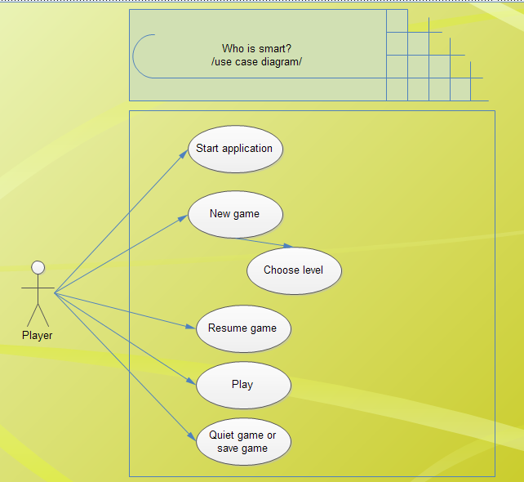

If user want to play game that start application

Application is beginning you two chance. First chance is play new game. If you want new game

You must choose level(high , medium, easy)

High : ” “ or “x2”

Medium : “\*”

Easy : “+” or ” –“

Second chance is play resume game. If you saved last game continue last game.

You have 3 stars.

If your answer is rigth, you will find a star. If your stars are 5, you are smart.

If your answer is wrong ,you lost a star.

If your stars empty, game is over.( If you want, play again.)

If you want exit game. 